**26/08 – Source bdy**

* Definition of a “source region” which is a subset of “PhiBd” without obstacles and not too close from the attractant.
* The update of b is computed for b+PhiSrc*DensityInitValue to account for a steady flow of bactery  
  > The first results are not consistant: expected from the sides (X direction) but nothing from bottom (Y dir). Investigation required
* A first bug has been found in UpdateY where b was cut on PhiDef at the end. The impact should be naught. Confirmed with simulation.  
  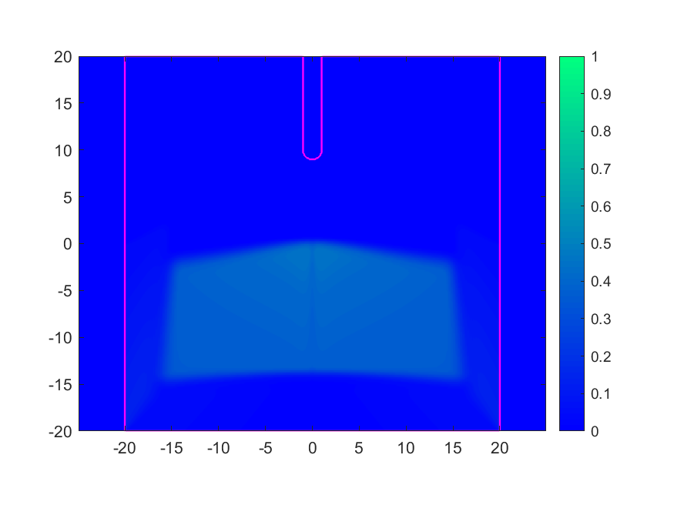
* The study of the numerical fluxes shows a similar behaviour for X dirLeft and Y dirRight. Why the density is not flowing then ?